# CHAPTER # 5

**Storage:**

Primary memory is directly accessible to the processor and is used to store data and program that are in current use. The control unit does not have direct access to data that is stored anywhere outside the processor or main memory. However, this storage is limited in size and volatile. We need some storage device that is not temporary in nature and that does not have the same restrictions of size as that of main memory. Such a device is called secondary storage. Storage is also known as secondary storage and mass storage. Secondary storage devices are categorized or magnetically:

* Mean by which the data is stored, optically or magnetically
* The technique used for storage of the data, sequential storage or direct access storage
* The capacity of the medium, how much can be stored on it
* Portability of the medium, can it be moved around easily
* Access time to the data stored

Storage is required for following reasons:

|  |  |
| --- | --- |
| **Memory** | **Storage** |
| Expensive | Cheap |
| Small capacity | Large capacity |
| Fast access | Slow access |
| Connects directly to the processor | Not connected directly to the processor |
| Smaller in size than storage | Bigger in size than memory |
| Program are copied from storage during execution | Programs are stored in storage when no execution takes place. |

Two types of Secondary Storage Devices are:

1. Magnetic Disk **2.** Optical Disk

**Magnetic Disk:**

Magnetic disk is the most widely used storage medium that consists of a circular piece of thin, flexible magnetic media encased in a square or rectangular plastic wallet. Information can be recorded on or read from the magnetic surface. A disk must be formatted before it can be used. The formatting process prepares the disk so that it can store data.

Formattingis a process that creates sector and tracks on disk. Each track divided into sectors. The magnetic disk is a random access storage media. It means that any part of the disk is directly accessible. Floppy disk, hard disk are type of magnetic disks.

1. **Hard disk:** Hard disk is a type of magnetic disk. It is also called fixed disk because it is fixed in the

system unit. A hard disk consists of several circular disk called platters sealed inside a containers.

1. **Diskette:** Floppy disk is also called diskette. It consist of a thin plastic disk coated with magnetic

material. This disk is enclosed in a plastic jacket.

1. **Tape** In computers, tape is an external storage medium, usually both readable and writable,

can store data in the form of electromagnetic charges that can be read and also erased. A tape drive is the device that positions, writes from, and reads to the tape.

**Optical Disk (Optical Disc):**

An optical disk is any computer disk that uses optical storage techniques and technology to read and write data. It is a computer storage disk that stores data digitally and uses laser beams (transmitted from a laser head mounted on an optical disk drive) to read and write data.

Optical disk use laser technology to read and write data. The laser stands for Light Amplification through Stimulated Emission of Radiation. Laser beam writes on the surface by creating small pits (hole) in the disk.

Optical disc commonly store data in a single track that spirals from the center of the disc to the edge of disc. Optical drive red data by focusing laser beam on the surface of the disc. A laser detects the presence of a pit. The presence of a bit indicates 1 and absence of pit indicates 0. Laser beam converts these pits into digital data. Optical disc storage capacity is from 700 MB to several GB. Main categories of optical laser disks are CD and DVD.

1. **CD:** CDstands for Compact Disk. It is most widely used media today. A single CD can store

from 650 MB to 1 GB of data. The content of CD can be read by CD drives. A CD drive can only read CD discs, a DVD drive can only read DVD and CD discs because these discs are read by light (optical).

1. **DVD**: DVD stands for (Digital Versatile Disc) is an optical disc technology that is expected

to rapidly replace the CDROM disc (as well as the audio compact disc) over the next few years. The digital versatile disc (DVD) holds 4.7 GigaBytes of information on one of its two sides, or enough for a 133-Minute movie.

**Input Devices**

An input device is a hardware component that is used to enter data and instruction into a computer.

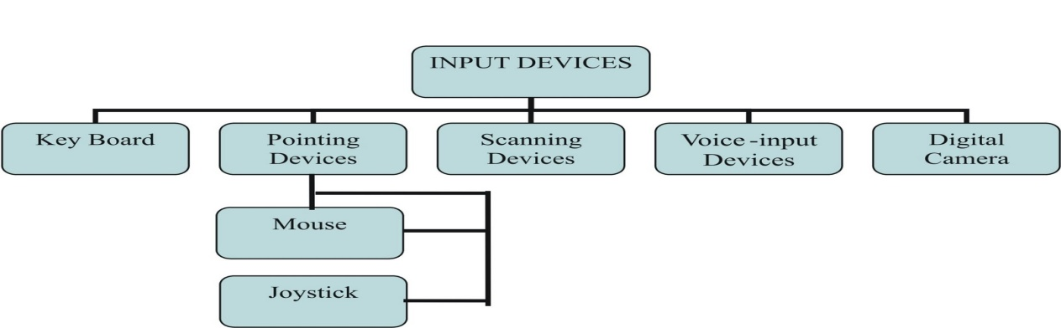

**Keyboard:**

Keyboard is the most commonly used input device. Keyboard is the standard input deices used to enter textual data into the computer. The layout of a keyboard is just like a traditional typewriter. The buttons on the keyboard are called keys. The arrangement of keys on a keyboard is called layout. A typical keyboard can have 101 to 104 keys. Most popular keyboard layout is QWERTY. The letter Q, W, E, R, T and Y appear on the top raw of the main area of a keyboard.

The keys on computer keyboard are often classified as follows:

1. Numeric Keypad
2. Function Keys
3. Alphanumeric Keys
4. Backspace key
5. Caps Lock key
6. Tab key
7. Modifier Key

**Pointing Devices**

* Mouse
* Joystick
* Digital Camera
* Microphone
* Scanner

**Mouse**:

A mouse is a small device that a computer user pushes across a desk surface in order to point to a place on a display screen and to select one or more actions to take from that position. The mouse first became a widely-used computer tool when Apple Computer made it a standard part of the Apple Macintosh. Today, the mouse is an integral part of the graphical user interface (GUI) of any personal computer. The mouse apparently got its name by being about the same size and color as a toy mouse.

**Joystick**:

In computers, a joystick is a cursor control device used in computer games. The joystick, which got its name from the control stick used by a pilot to control the ailerons and elevators of an airplane, is a handheld lever that pivots on one end and transmits its coordinates to a computer. It often has one or more push-buttons, called switches, whose position can also be read by the computer.

**Digital Camera:**

A digital camera records and stores photographic images in digital form that can be fed to a computer as the impressions are recorded or stored in the camera for later loading into a computer or printer. Currently, Kodak, Canon, and several other companies make digital cameras.

**Microphone:**

A device that converts sound waves into audio signals. These could be used for sound recording as well as voice chatting through internet.

**Scanner:**

A scanner is a device that captures images from photographic prints, posters, magazine pages, and similar sources for computer editing and display. Scanners come in and flatbed types and for scanning black-and-white only, or color. Very high resolution scanners are used for scanning for high-resolution printing, but lower resolution scanners are adequate for capturing images for computer display. Scanners usually come with software, such as Adobe's Photoshop product, that lets you resize and otherwise modify a captured image.

**Output Devices**

* Monitor
* Plotter
* Speaker
* Printer

**Speaker**:

A device which converts electronic signals from a computer sound card to speech or music. Headphones will also perform the same function. Most new home computers have sound cards and many newer monitors have built-in speakers.

**Modem**:

Modem is output as well as input device at the same time. It receives the data (analog signal) coming through telephone line, converts them to digital signals and sends them to computer to which it is attached. It also receives the data from computer and changes it to analog signals.

**Printer:**

A printer is an output device that prints character, symbols and graphics on paper. The printed output is called Hard Copy. Print resolution is commonly measured in dots per inch (dpi).

Different categories of printers are as follows:

1. Impact Printers
2. Non-Impact Printers
3. **Impact Printers:**

Impact (which means "to hit") an impact printer work like a typewriter. It prints characters or image by striking a print hammer or set of pins against an inked ribbon. The ink is pressed from ribbon on the paper to produce the output. Impact printer is the oldest print technologies which are still produced. The impact printer are used where low cost printing are required. Three most common forms of impact printers are dot matrix, daisy wheel printers and line printer.

1. **Dot-Matrix Printers:** Produce**s** characters by striking pins against an ink ribbon to print

closely spaced dots in the appropriate shape. The shape forms a number, alphabet or other special characters. On receiving instructions from the PC, the printer can push any of the pins out the combination. By punching out pins in various combinations, the print head can create alphanumeric characters.

When pushed out from the cluster, the producing pins ends strike a ribbon, which is held in place between the print head and the paper. When the pins strike the ribbon, they press ink from the ribbon onto the paper. The print head on a dot matrix printer can contain nine to twenty four pins.

Dot-matrix printers are relatively expensive and do not produce high quality output; however, they can print multiple copies of a page at a time.

The speed of dot matrix printer is measured by the number of character it can print in one second. The speed of most dot-matrix printer ranges from 350 to 1100 character per second (cps). Dot matrix printers do not provide high quality output. Printing cost of these printers is very cheap.

1. **Daisy Wheel Printer:** It is similar toa typewriter. It uses a print wheel. The print wheel is

called daisy wheel. Each petal of daisy wheel contains a character. Daisy wheel printers are loud and slow. They cannot print graphics, and cannot change font unless the print wheel is physically replaced. Daisy wheel printers are generally not used in modern computing environment.

1. **Line Printers:** ALine printeris a fast impact printer. It work like a dot matrix printer

but use a special wide print head that can print an entire line of text at one time. Its speed is measured in line per minute (lmp). Line printer has speeds ranging from 300 LMP to 2400 LMP.

Because the nature of print mechanism, line printer are much faster than dot-matrix and daisy wheel printer, however they tend to be quit loud, have limited font capability, and often produce lower print quality than recent printing technologies.

Because line printers are used for their speed, they used special paper with pre-punched holes along each side. This arrangement helps to continue printing at high speed till the paper runs out.

Two types of Line Printers are as follows:

* **Band Printer:**

A band printerprint characters by striking hammers on a rotating horizontalband. A band contains the shapes of numbers, letter and other characters. A good quality band printer can generate 2,000 line of text per minute.

* **Chain Printer:**

Chainprinter is similar to band printer**.** It contains complete set of characters on several sections of a chain. The chain rotates at high speed. Print hammer are located at each horizontal print position. The paper and ribbon are located between the hammers and the chain. The chain rotates and the hammer strike when the proper characters are in front of the print position.